

DIVINE SECONDARY SCHOOL KITALA

BEGINNING OF TERM TWO EXAMS 2024

**BIOLOGY S.3**

**TIME: 2 HOURS**

**INSTRUCTIONS TO SEMI CANDINDATES**

**ANSWER ALL QUESTIONS**

**NAME……………………………………………………………………………………………………**

**LIN…………………………………………………………………………SIGN………………………..**

1. At breakfast and evening tea, your school provides milk and cooked cassava to the learners as suggested by the government of Uganda.

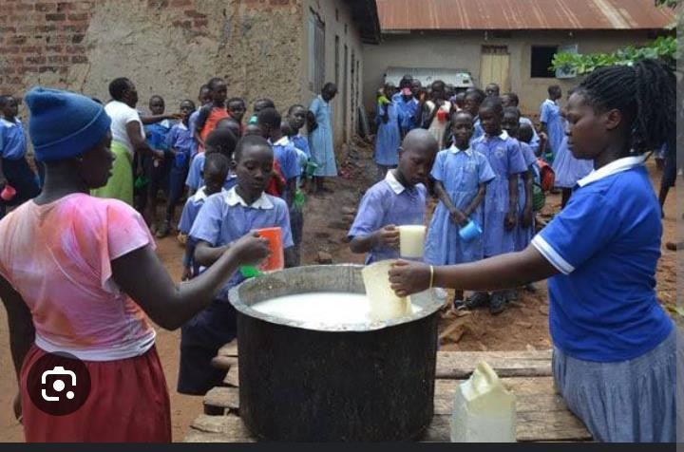

1. Name the food nutrients that the school mess provides to its learners at breakfast. (02scores)
2. Some learners after eating this kind of food, they complain of over dosing and end up missing lessons due to sleeping in class. Explain why do learners dose after having some meals. (02scores)
3. (i)State all the enzymes inthebodythatenablesthelearnerstobreakdownthefoodsubstancestheyareprovided at breakfast. (03scores)
4. Name the end products of the foods they get at break fast. (02scores)
5. How is glucose used in the body of organisms? (03scores)

After digestion, the products mentioned above are absorbed in to blood system by the ileum and the colon.State three ways in which the ileum ismodifiedtoabsorbthesematerials.

1. **Read the passage below and use it to answer questions that follow.**

Your immune system is what protects you when germs try to invade and attackon your body which can cause you to become sick. Your body has microscopicwarriorsthatfightinvasivegermsand help your body get rid of them.Your body is pretty good at defending you against the jams. Your body systems areyourfirstlineofdefenseagainstgerms.Forinstance,theskintriesto stop germs from entering the body, the lungs, saliva and the digestive system all try to trap germs to destroy them or to help them exit your body. Your blood also tries to destroy harmful germs. Think about when you sneeze your body is trying to getrid of something that got into your nose!! If this first line of defense does notwork, there is also a second line of defense that helps fight harmful germs inordertokeepyouhealthy.

Your second line of defense is when your body makes antibodies that help kill ordestroy harmful disease or illnesses causing germs. These antibodies that yourbody creates are actually proteins that go on the attack when your body getsharmful germs that are not supposed to be a part of bodies of your body. Thinkabout when you get a cold or a flue. Your body works hard making antibodiesthat will destroy the cold or flu Germs, when they are successful you begin tofeel better. Vaccinations act in a similar way as they contain antibodies as well.The antibodies in the vaccinations help prevent disease and illness like measles,chicken pox and specific types of flus. It is also important to live a healthylifestylebyeatingnutritiouslyandgettingexercisedailytoboostyourimmunity.

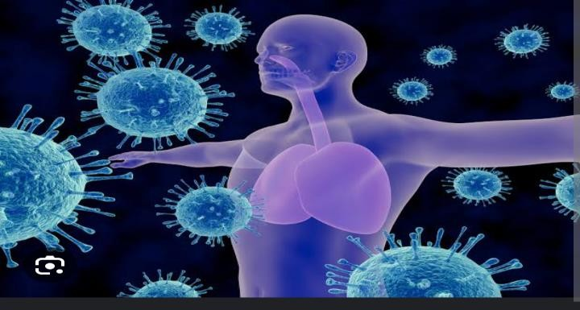

1. (i)Defineimmunityusingyourown words. (02scores)

(ii)Describehowyourbodyfightsagainstgerms. (02scores)

1. (i)Whatwouldhappenifyouhadnoimmunity? (01score)

(ii)Howdovaccinesassistwithimmunity? (01score)

1. Describehowthefollowinghelpinimmunity.
2. Mucus (01score)
3. Whitebloodcells (02scores)
4. Sneezing (01score)
5. Statehowthefollowingacquiretheirimmunity:
6. Embryos (01score)
7. Babies. (01score)

Explainhowimmunizationorvaccinationprovidedimmunityofthebody. (03scores)

1. Organisms require gases to run some processes. For animals, they requireoxygen which is usually obtained from their environment. Man uses therespiratorysystemto takeinthisairthatcontainstheoxygen neededfromthe

atmosphere. Through answering the Items below, you will be to learn moreabout theprocessof breathing andgasexchange.

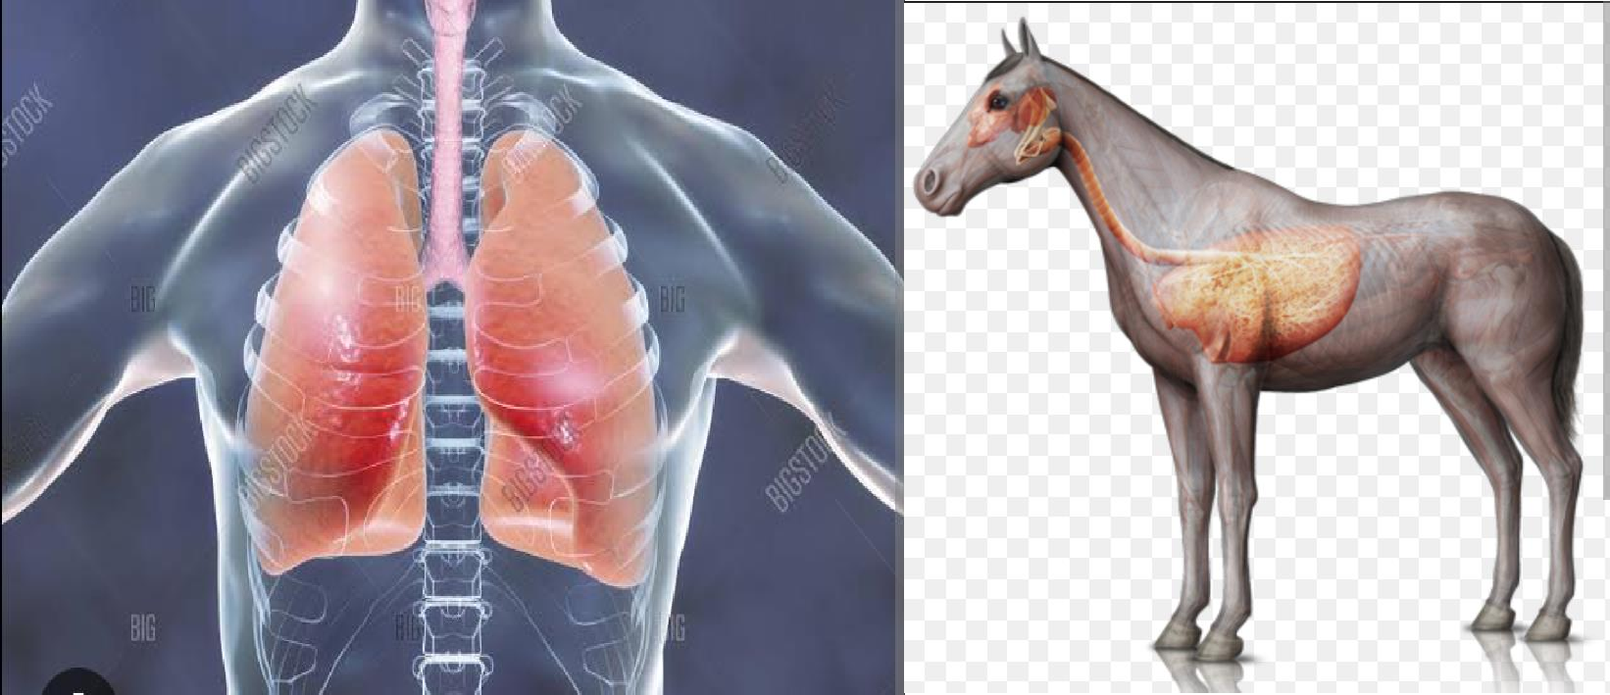

1. Mention any four organs that make up the respiratory system of man.

(04

scores)

1. (i) From the organs mentioned above, state the exact organ or structures through which gases are exchanged. (01score)
2. What is the difference between the function of the nose and lungs (02scores)
3. What do plants use for breathing? (01score)
4. During breathing,the followingprocessesoccurinthebodysoasaircanenterman. The volume of the chest increases. Air reach in oxygen enters through the nose and travels to the lungs. Intercostal muscles of the rib cage contract. Pressure of the chest decreases below atmospheric pressure. The rib cage moves upwards and outwards. The above process is not in its order.

You are required to sort and organize the above process in its normal flow for breathing to (05scores)

1. Explain why breathing is very important to animals. (02scores)

**END**